Customer Contact: Media Contact:
Advantech Europe GmbH Advantech Europe GmbH
Customer Care Center Martin Skiba
Toll Free: 00800 24 26 80 80 Phone: +49 (0)211 97 477 363
CustomerCare@advantech.eu martin.skiba@advantech.de

Latest Advantech Embedded Boards Based on New Intel® Atom™ Processor E6xx Series

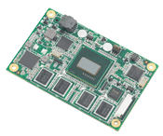
Milano, Novembre 2010 –Advantech, the embedded platform and integration services provider, announces a new full range of embedded boards based on the latest generation of Intel® Atom™ processors. Advantech platforms based on the Intel® Atom™ processor E6xx series (formerly codenamed Tunnel Creek), range from Computer On Modules (COM) and PC/104 CPU modules, to 3.5” Single Board Computers (SBC). This is the first architecture by Intel to adopt the open PCI-Express standard to connect to any third party chips giving developers even greater flexibility for adding greater functionality. These low-power platforms provide energy-efficient and environmentally responsible solutions, and serve a wide range of applications targeted at compact portable devices, hand-held devices, and ultra low power applications.

Full Spectrum of Intel Atom Processor-based Embedded Form Factors

Specifications in the embedded market are highly dependant on their application. To utilize the strength of these latest Intel Atom processors, Advantech will offer a range of products that provide modularity, scalability and flexibility to engage with today’s diverse set of embedded application requirements. The simple addition of a standard PCIe interface means that embedded designers can easily add a variety of different chips to the Intel Atom processor E6xx series to create flexible embedded designs with minimal cost.

Flexible and modular platforms such as Advantech’s SOM-7564 (COM-Ultra) are super compact 84 x 55 mm (3.3" x 2.17") boards with built-in Advantech iManager for ultra low power designs. SOM-3564 (QSeven) 70 x 70 mm (2.76” x 2.76”), and SOM-6764 (COM-Express Compact) at 95 x 95 mm (3.74" x 3.74") are also targeted at compact portable devices and are suitable for all kinds of extended temperature environment applications.

Other stackable single board computers such as PCM-3364 (PC/104 in 96 x 90 mm), and PCM-9364 (3.5” SBC in 146 x 102 mm) integrate all functions including: LVDS, CRT, Ethernet, USB client, Mini-PCI express, UART, GPIO, CFast and CAN bus onto one small form factor. PCM-3364 and PCM-9364 were designed with fanless thermal solutions for easier system integration. These models are ideal solutions for vehicle, medical, POS, CNC, and extended temperature applications.

Finally, SOM-AB5500 is a 3.5” carrier board (for SOM-7564) with smart battery manager for hand-held devices. All these rugged, compact platforms help lower Bill Of Materials, increase platform scalability, and help produce better application-specific products. And because all these modular platforms are powered by Intel Atom E6xx series processors, they enable greater density with ultra low power consumption, and meet the diverse I/O demands of today’s carrier boards.

Advantech not only provides a comprehensive range of Intel Atom processor-based embedded boards, but also multi OS support, including Windows 7, XPe, WinCE, QNX, and Linux. Plus, a variety of intelligent API’s are bundled with the new boards to facilitate application development. To find out about the new Intel Atom processor-based boards and innovative embedded services, visit the website or contact your local sales.

About Embedded Core Services –Advantech Embedded Core Services offers design-in oriented services. These streamlined solutions broadly integrate embedded boards, peripheral modules and software. This dedicated focus on Embedded Design-in services fulfills electronic engineering demands at their design-in phase, and brings benefits that shorten the design and integration cycle, minimizing uncertainty and risk. www.advantech.com/EmbCore

Advantech Co., Ltd. (TAIEX: 2395) – Founded in 1983, Advantech delivers trustworthy industrial computing solutions that enable intelligent applications. Our operation is divided into two segments: Branded & Solution Business and Embedded Design-In Business. Advantech is a Premier Member of the Intel® Embedded Alliance. We cooperate closely with solution partners to provide products and customized solutions in a wide array of applications. Advantech operates an extensive support, sales and marketing network in 18 countries and 39 major cities to deliver fast time-to-market services to our worldwide customers. (Corporate Website: www.advantech.com)

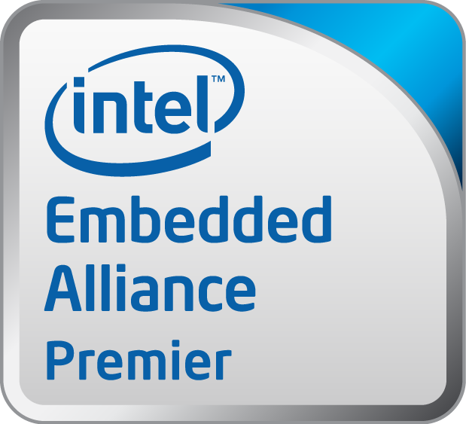
Intel and Atom are registered trademarks of Intel Corporation in the United States and other countries.

